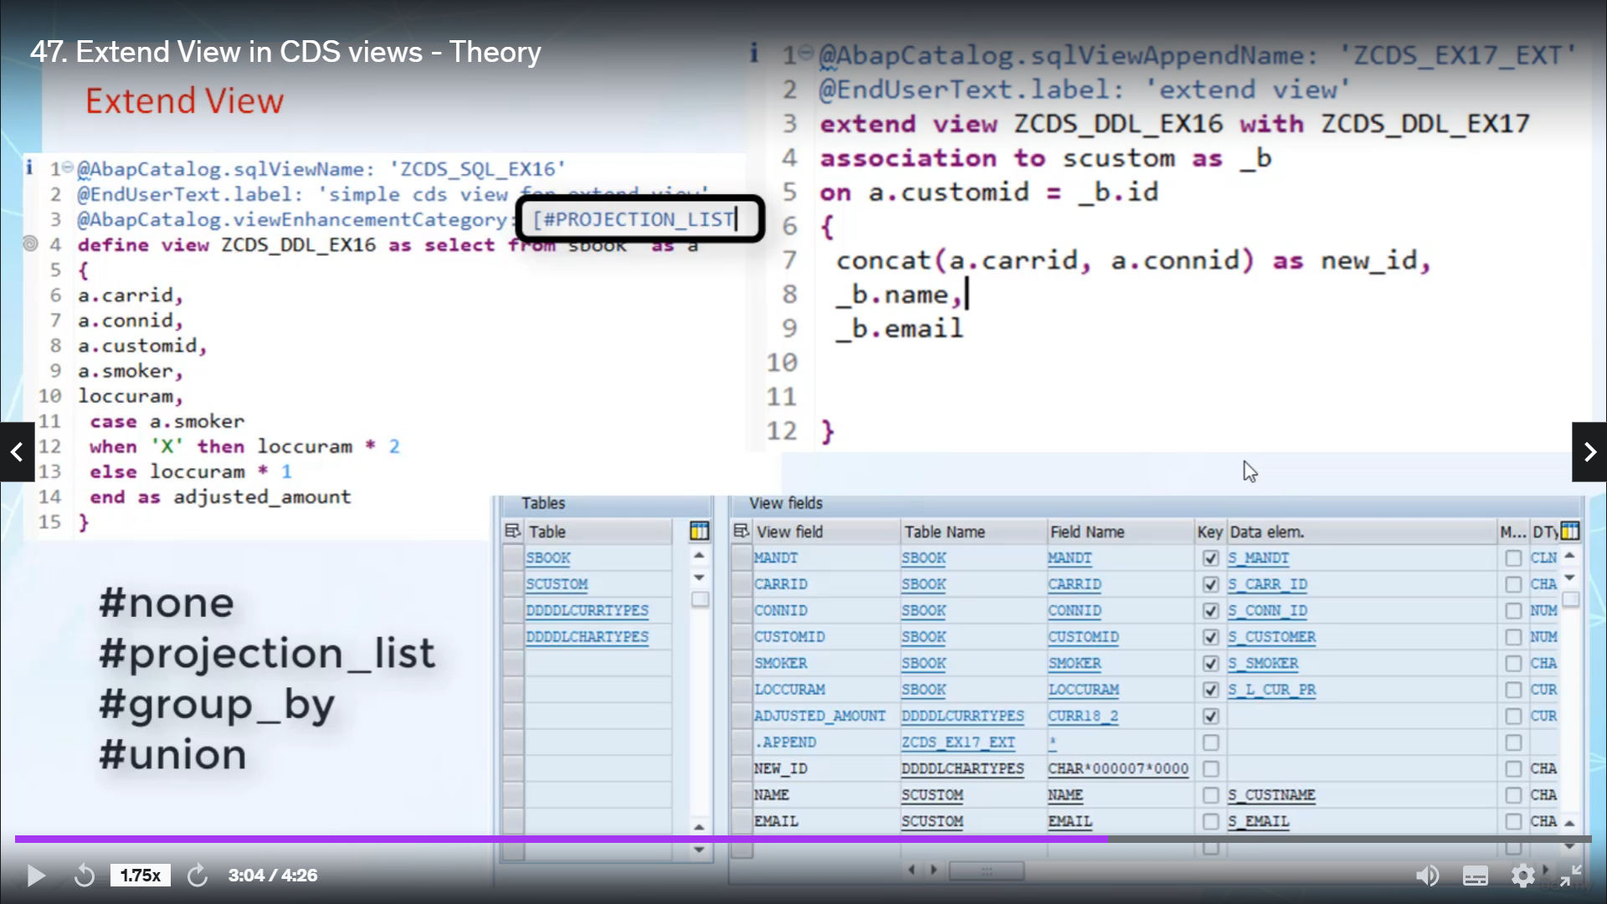

Hi, welcome back in the studio, I will tell you how you can extend our Bezzerides view without doing

any changes in orignal Abbasids view, solid start.

Extreme view is used to extend standard or custom 3D view without making any changes to the original

3D view.

In Eskil view of orignal, studious view, the classical urban view is created as a pain in a revolutionary.

This is very much similar to as a structure it used to extend the dentistry tables.

Like classical, I believe you see this, you can add elements to this list, new is the fact that an

external view can also define additional associations.

And this can be used, for example, to define an association to customer specific database table or

seediest to.

I see these two explosions are defined in dedicated tools via detailed statement.

We are creating the digital tools you have to specify the name of the view that you want to extend and

the name of nuclease entity and the name of a school view of.

The annotation about catalogued or obscured view of pen name must be specified before the extinction

itself is defined using external view.

And you know, the name of a school, you cannot be specified.

After a stunning interview using exit interview, it also aired classical, a painting, a school view

in the Arab dictionary.

As you know, for our benefit to transport people that are living in spaces, they're desert and Vyvyan

in our cities, you know, sitting in space exist with the release of seven point five one, it is possible

to exchange views that contain aggregations and unions.

But to do so, the target has to actually allow this via an audition ABAB catalog, that view enhancement

category.

The annotation and these annotation may be used with common stock values in square bracket, and these

values can be non traditionalist group by a union.

If you don't want to allow extension for the original view, then you have to specify no.

If you want to allow an extension of the list and additional associations, then you have to specify

production list in square brackets.

If you specify group back, it's good because that means extensions of group are closer, but when we

did.

Similarly, if you specify Union Square bracket, that means extinction of select list of cities with

union clubs are allowed.

After activating an external review, Spider Lexing welcomes in particular to the issue indicating that

this view has been extended using other view, when you please ponder over this board, a dialog box

will open with a list of existing extensions to open the definition of judicial exchange.

You you're to click on the name in the list.

Now, we have covered all the necessary trading related to external view.